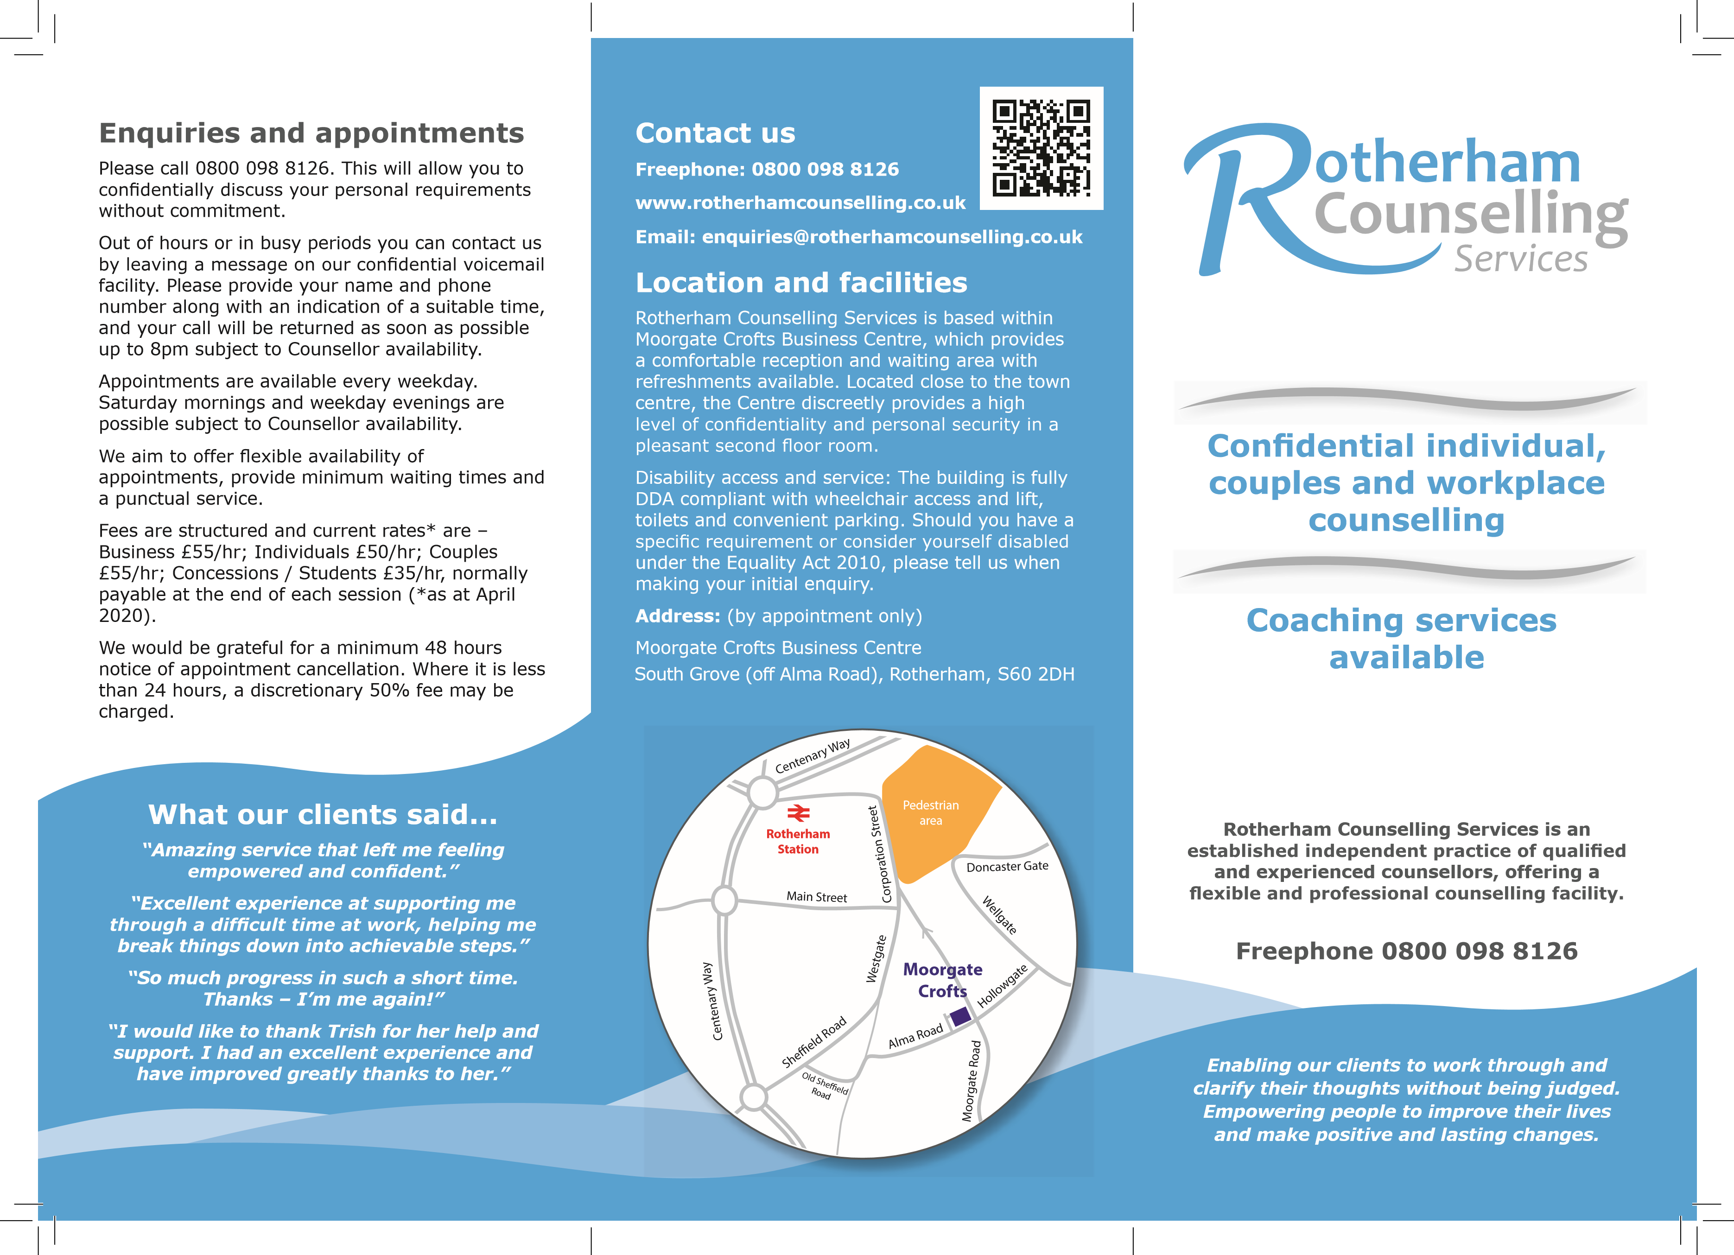

What is therapy?
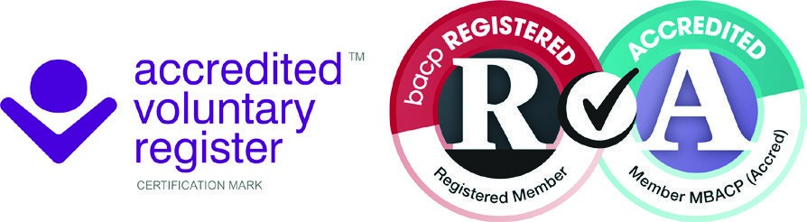
Therapy is time set aside by you and the therapist to look at what has brought you to therapy. This might include talking about life events (past and present), feelings, emotions, relationships, ways of thinking and patterns of behaviour. The therapist will do their best to help you to look at your issues, and to identify the right course of action for you, either to help you resolve your difficulties or help you find ways of coping. Talking about these things may take time, and will not necessarily all be included in one session.
British Association for counselling and Psychotherapy, Fact Sheet C2 February 2017

Our Counsellors
049679

Patricia Kent MBACP (Accred)
Diploma in Counselling
Advanced Diploma in Couples Counselling (Relate)
(Proprietor)
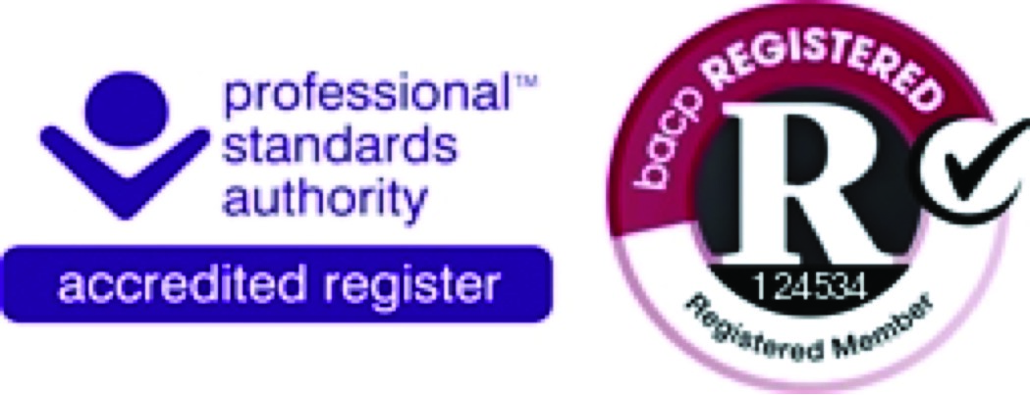

Lucy Rotherham MBACP
Diploma in Counselling
(Associate Counsellor)
Membership Number: NCS19-08668 Linda Panek (MNCS)
Diploma in Counselling
Coaching Services

Services

service which is accessible outside of standard working hours, within an anti-oppressive, antidiscriminatory and non-judgemental framework.
Services are designed to meet the needs of people over the age of 18 seeking private counselling on a fee-paying self-referral basis, as well as referrals from private, GP and work-organisations (on or off-site).
Our Counsellors offer a range of counselling approaches and specialities to match with client needs. Issues covered include:
- Anger Management • Poor self-esteem /
- Anxiety or low motivation depression • Relationship
- Bereavement, loss or terminal illness ^{dilemma}
(
Associate Counsellor
)
- Communication • Response to
physical illness
- Financial worries • Stress and/or panic attacks • Life stage changes /
life crisis • Work place issues
Hypnotherapy and work/life coaching are available as necessary.
Telephone counselling can be offered to new and existing clients who are having difficulty coming to the centre, available by pre-booked appointment. We also offer video counselling via Zoom.

national resource information as appropriate.
We are Members of the British Association for Counselling and Psychotherapy (BACP) and also the National Counselling Society (NCS) we are bound by their ethical frameworks for Good Practice in Counselling and Psychotherapy and subject to the Professional Conduct Procedure.

Initial assessment
During an initial telephone assessment the Counsellor will clarify the basis on which counselling is to be given, provide information available and undertake a general initial assessment. This includes method, duration, fees and confidentiality. Changes can be subsequently made only by agreement of the Client and Counsellor. Issues outside of our range of expertise are identified, or where the client(s) might be better served by specialised agencies, e.g. drug or alcohol counselling.
How long will Counselling take?
Depending on individual needs, this may range from a few sessions (sometimes a single session
months. Generally sessions are an hour long, at an agreed frequency to give the best support, with
availability.
Short-term counselling (if suitable) can facilitate “solution-focused” counselling work, maximising

being self-empowering yet client-supportive. After assessment this would normally be offered as a contracted set number of sessions and be regularly reviewed.
Longer-term personal development or “personal therapy” work programmes are individually tailored to a client’s agenda.
A free telephone assessment of client needs is done before a commitment to continued counselling is made, without obligation on either side.

